**LAB 7 -OOPS**

**NEHAL MEHTA**

**209302329**

**SEC-F**

**1.**

import java.util.ArrayList;

public class ArrayListDemo {

public static void main(String[] args)

{

ArrayList<String> arlTest = new ArrayList<String>();

System.out.println("Size of ArrayList at creation: " +arlTest.size());

arlTest.add("B");

arlTest.add("I");

arlTest.add("T");

arlTest.add("S");

System.out.println("Size of ArrayList after adding elements: "+arlTest.size());

System.out.println("List of all elements: " + arlTest);

arlTest.remove("B");

System.out.println("See contents after removing one element: " + arlTest);

arlTest.remove(2);

System.out.println("See contents after removing element by index: " + arlTest);

System.out.println("Size of arrayList after removing elements: " + arlTest.size());

System.out.println("List of all elements after removing elements: " + arlTest);

System.out.println(arlTest.contains("T"));

}

}

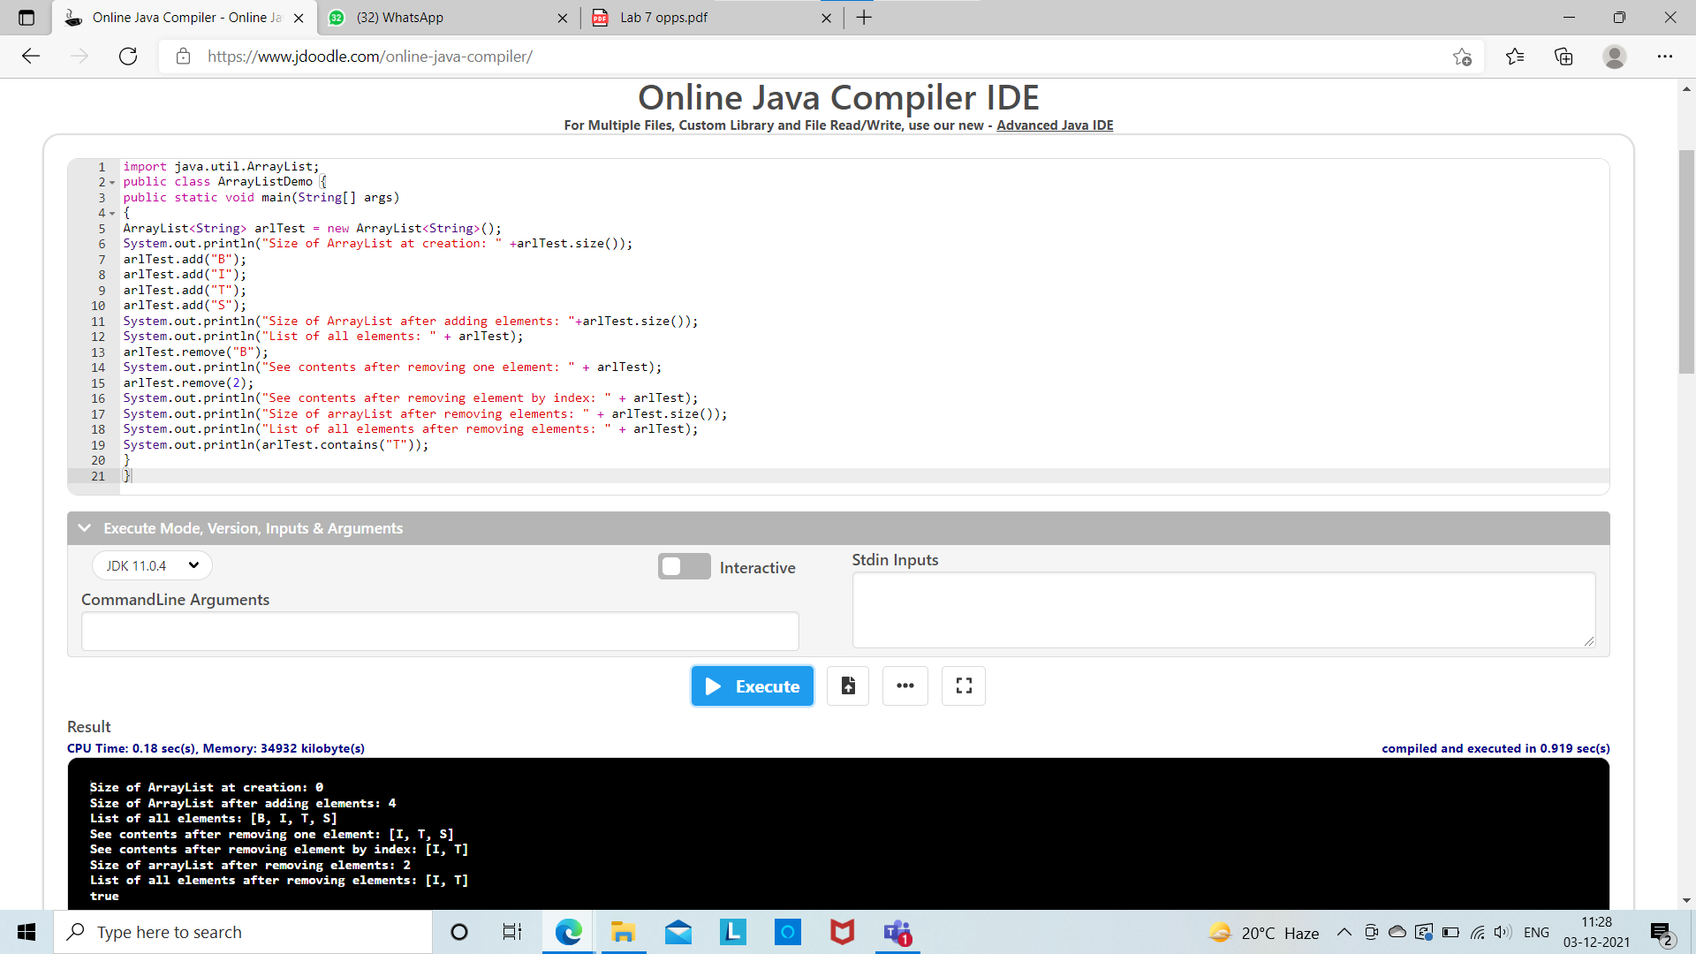

**2.**

import java.util.*;

class Student {

private String name;

private String gender;

private int age;

public Student(String name,String gender,int age) {

this.name=name;

this.gender=gender;

this.age=age; }

public String getName()

{return name;}

public String getGender()

{return gender;}

public void setName(String name)

{this.name=name;}

public String toString()

{return name+" "+gender+" "+age;} }

public class TestStudentList {

public static void main(String args[]) {

ArrayList<Student> studentList = new ArrayList<Student>();

studentList.add(new Student("Ramesh","Male",18));

studentList.add(new Student("Reeta","Female",19));

studentList.add(new Student("Seema","Female",18));

studentList.add(new Student("Suresh","Male",20));

System.out.println("Original contents of studentList:");

Iterator itr = studentList.iterator();

while(itr.hasNext()) {

Object element = itr.next();

System.out.print(element +"\n"); }

System.out.println();

ListIterator<Student> litr = studentList.listIterator();

while(litr.hasNext()) {

Student element = (Student)litr.next();

if(element.getGender().equals("Male"))

{element.setName("Mr."+element.getName());}

else

{element.setName("Miss."+element.getName());}

litr.set(element); }

System.out.println("Modified contents of studentList: ");

itr = studentList.iterator();

while(itr.hasNext()) {

Object element = itr.next();

System.out.print(element + "\n"); }

System.out.println();

System.out.println("Modified list backwards: ");

while(litr.hasPrevious()) {

Object element = litr.previous();

System.out.print(element + "\n"); }

System.out.println(); } }

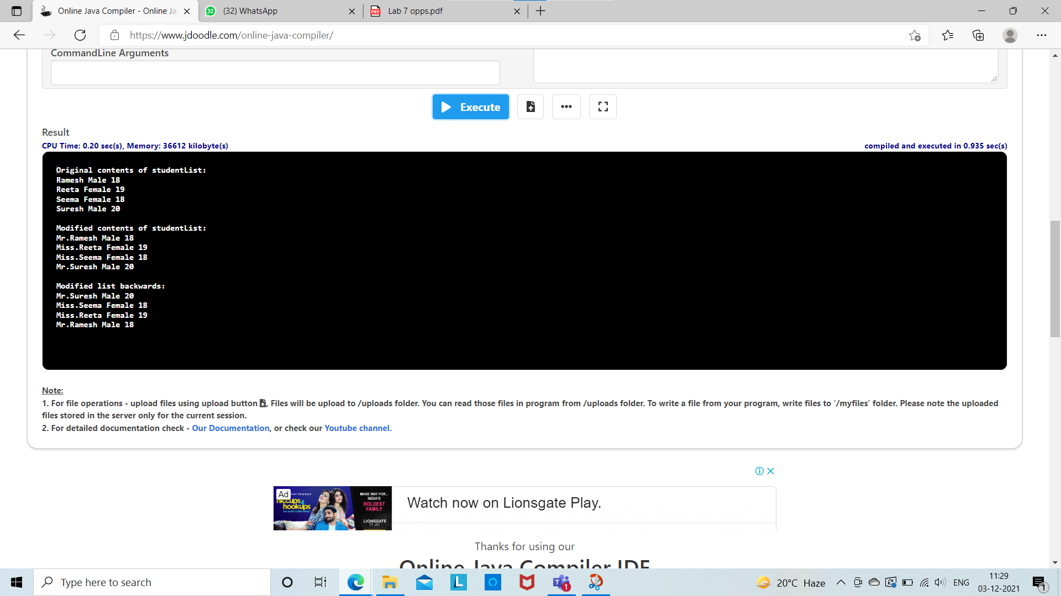

**3.**

import java.util.*;

class Account {

private long acctNumber;

private double balance;

private String name;

public Account(long acctNumber, double balance, String name) {

this.acctNumber=acctNumber;

this.balance= balance;

this.name= name;

}

public long getAcctNumber()

{return acctNumber;}

public double getBalance()

{return balance;}

public String getName()

{return name;}

public void setAcctNumber(long acctNumber)

{this.acctNumber=acctNumber;}

public void setBalance(double balance)

{this.balance= balance;}

public void setName(String name)

{this.name= name;}

public String toString()

{return "Account: "+name+" Balance: "+balance+" Account No. "+acctNumber;}

}

class Bank{

private ArrayList<Account> accts = new ArrayList<Account>();

int maxActive;

public boolean addAccount (Account newone){

if(accts.size()>30)

{return false;}

else{

accts.add(newone);

return true;

} }

public boolean removeAccount (long acctnum) {

Account a;

Iterator<Account> itr= accts.iterator();

while(itr.hasNext()) {

a=itr.next();

if(a.getAcctNumber()==acctnum) {

itr.remove();

return true;

} }

return false;

}

public double deposit(long acctnum, double amount) {

Account a;

Iterator<Account> itr= accts.iterator();

while(itr.hasNext()) {

a=itr.next();

if(a.getAcctNumber()==acctnum) {

a.setBalance(a.getBalance()+amount);

return a.getBalance();

} }

return -1;

}

public double withdraw(long acctnum, double amount) {

Account a;

Iterator<Account> itr= accts.iterator();

while(itr.hasNext()){

a=itr.next();

if(a.getAcctNumber()==acctnum){

a.setBalance(a.getBalance()-amount);

return a.getBalance();

} }

return -1;

}

public String toString(){

String str="";

for(int i=0;i<accts.size();i++){

str+=accts.get(i).toString();

str+="\n";

}

return str;

} }

public class TestDriver {

public static void main(String args[]) {

Bank b = new Bank();

b.addAccount(new Account(26000,300,"Ayushmaan"));

b.addAccount(new Account(28000,400,"Ayushmaan"));

b.addAccount(new Account(30000,500,"Ayushmaan"));

b.addAccount(new Account(32000,600,"Ayushmaan"));

b.addAccount(new Account(34000,700,"Ayushmaan"));

System.out.println(b);

b.removeAccount(28000);

System.out.println(b);

b.deposit(30000, 400);

System.out.println(b);

b.withdraw(32000, 300);

System.out.println(b);

} }

